Structure of the Excretory system

Each of our kidneys are about 11cm long, roughly the size of a fist. They sit either side of our backbone under the lowest ribs in an area known as the flank.
The kidneys are part of the excretory system and carry out the following roles,
- They remove urea and other waste products from the blood.
- They adjust salt levels in the blood.
- And they adjust water content of the blood.
For pharmacists and other healthcare workers to look after patients it is important that they know how the kidneys work.

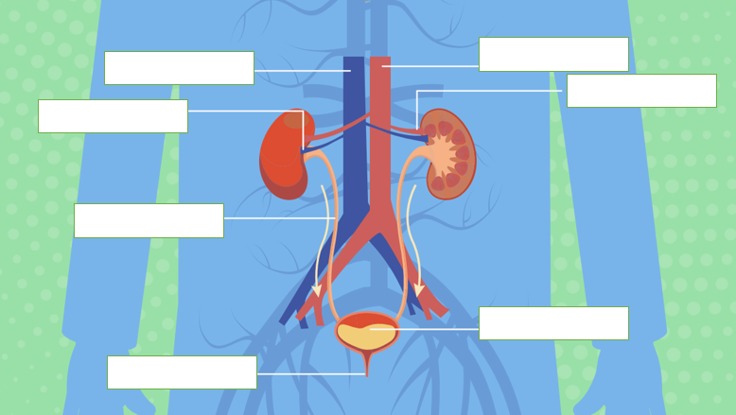
Identify the parts of excretory system using the letters below.
- Aorta
- Bladder
- Kidney
- Renal artery
- Renal vein
- Ureter
- Urethra
- Vena cava

Explain the role of each part of the excretory system.
- __________________________________________________________________
- __________________________________________________________________
- __________________________________________________________________
- __________________________________________________________________
- __________________________________________________________________
- __________________________________________________________________
- __________________________________________________________________
- __________________________________________________________________

Structure of the kidney

Many metabolic processes in the body produce unwanted substances as well as useful ones. The waste products need to be removed from our body to keep us healthy. This essential process is carried out by our kidneys.

Our kidneys are made up of several parts. Identify the parts of the kidney using the letters below.

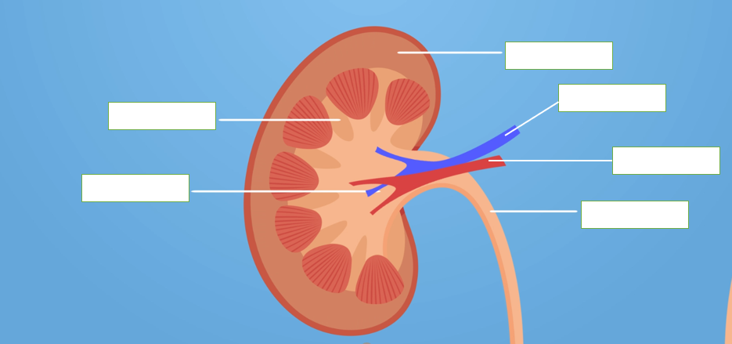

- Cortex
- Medulla
- Pelvis
- Renal artery
- Renal vein
- Ureter

Structure of the nephron

Filtration of the blood happens in the kidney nephrons.

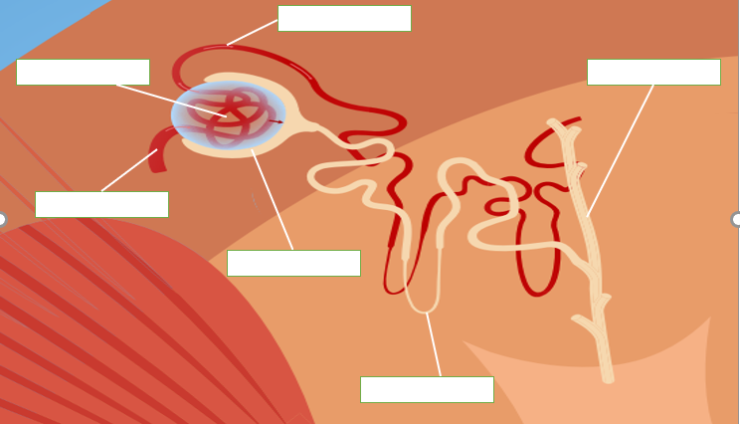

On the above diagram, identify the parts of the nephron using the letters below.
- Bowman’s capsule
- Capillary knot
- Capillary network
- Collecting duct
- Narrow arteriole
- Tubule
- Wide arteriole

Ultrafiltration occurs in the capillary knot where water, salts, glucose, and other small molecules pass out of the capillary. What allows this process to happen?
________________________________________________________________________________
________________________________________________________________________________
________________________________________________________________________________
________________________________________________________________________________

Osmoregulation, ADH and the negative feedback loop

Our kidneys work with our brain to determine how much water is reabsorbed. The amount of water reabsorbed in our kidney nephrons is controlled by anti-diuretic hormone (ADH). ADH makes the collecting ducts of the nephrons more permeable to water so that more water is reabsorbed into the blood. The whole process of water regulation is an example of a negative feedback loop.

On the diagrams below pick the correct word to fill the blanks to complete the negative feedback loop.
- More
- Less
- High
- Low

a.
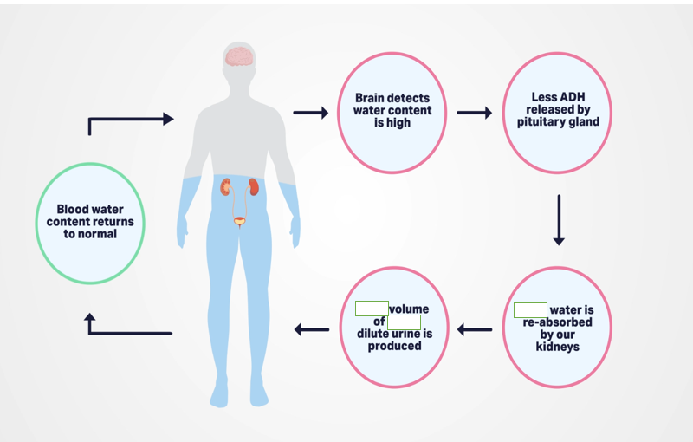

b.
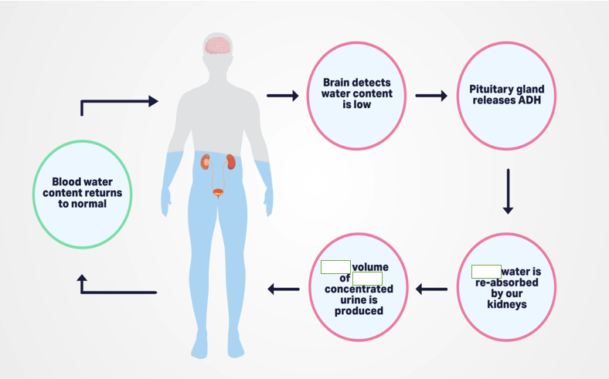

Our kidneys are key to our health and it is essential that pharmacists and other healthcare practitioners understand how they work to ensure that they can support patients to manage their illnesses and safely take their medicines.

