Wildflower Growing Guide
Rewilding Project

The flowers that are included in the Pharmabees seed mix are below:

Common Knapweed
Corn Marigold
Oxeye Daisy
White Campion
Dandelion
Corn Poppy
Corn Chamomile
Cornflower
White Clover
Bluebell

These flowers were chosen by the Pharmabees team. These flowers have been identified as part of a University research project to develop a wild flower seed mix which can be used to support pollinators and to promote biodiversity. These flowers have been identified through our research on honey. Honey with high antibacterial activity was analysed. The pollens found in the honey were identified through DNA analysis. We were able to identify the flowers in your seed mix. We are conducting additional research on these plants and need your help.
Please monitor your growing area and watch your flowers grow. We will be asking you to monitor your growing area for pollinators, and to collect some additional data for us. Thank you for being an important part of our research!

Instructions:
Choose a growing area around 1 meter squared. Firstly, remove all weeds, grass, and other plants. It is very important to remove weeds such as nettles, thistles, and Japanese knotweed. These weeds and grasses grow quickly, and will overtake your wildflower seeds if not removed. Cultivate the growing site to a depth of around 10cm. This can be done with a rake, or on large areas a plough. Sowing can take place throughout most of the year. The months of March/April/August and September are generally most suited. Mix the seeds before spreading. Ensure all the seed is mixed to ensure an even spread. Seed can be sown by hand for smaller areas, or with a spreader for larger areas. If you are planting seed in a pot, fill pot with soil, and rake the seed in.

Once the seeds have been sown, rake the area to mix the seed in the soil to an approximate depth of 0.5cm. Then you will want to lightly compact the soil by stepping on the area, or pressing with your hand. Do not step or press for too long, or the soil will become too compact. Congratulations! You have just planted your Pharmabees seed mix, which will help us in our research.

In the first year after sowing, weed control is important. If weeds are present they can be controlled by pulling the weeds out by hand. When you pull out weeds, be sure to pull out the roots as well, as many weeds can grow back from roots only. If you have a really nasty weed, such as Japanese knotweed, you can have an adult spray a weed killer, if you cannot remove it by hand. However please be careful if spraying, as you can kill the wildflowers as well. Always follow safety instructions on the bottle.

Remember, a weed is simply an unwanted plant. Dandelions are often considered a weed, but in this case we want them in our garden, so they are not a weed. If you like any of the weeds that show up in your growing area, feel free to keep them. However, they will take up space where our seeds will grow, so you will get less flowers growing from our seed mix.

If there is a drought, or long period without rain, please be sure to water your wildflowers. Wild Flowers should be cut twice a year, once in the spring and once in late autumn after the plants have produced seed. Cutting back the plants helps to eliminate any weeds, as well as to spread seeds. The late autumn cut will distribute seeds produced by the wildflowers.

Results:
You will only see the annual wildflowers in the 1st year. Annuals is the name for plants that grow and bloom only once. They will reseed themselves after the first year, and you will see new plants the next year. An example is corn flower. Perennial and Biennial plants will be seen flowering in the second year. Biennials are a name for plants that only bloom once every two years. They are still alive and growing in the first year, but you will not see them bloom until the second year. An example is foxglove. We do not have any true biennials in our seed mix. Perennials are plants that often take time to grow, but will bloom continuously year after year. An example is white campion. You will only see the annual wildflowers in the 1st year.

If there is a drought, or long period without rain, please be sure to water your wildflowers. Wild Flowers should be cut twice a year, once in the spring and once in late autumn after the plants produce seed. Cutting back the plants helps to eliminate any weeds, as well as to spread seeds. The late autumn cut will distribute seeds produced by the wildflowers.

Find out more about wildflower species:

https://www.wildlifetrusts.org/wildlife-explorer/wildflowers
https://www.plantlife.org.uk/uk/discover-wild-plants-nature/plant-fungi-species
https://www.rhs.org.uk/plants/search-form

For more information on how to identify common weeds: https://www.rhs.org.uk/advice/common-weeds

Annual- these perform their entire life cycle from seed to flower to seed within a single growing season (An example is Corn flower)
Perennial- they persist for many growing seasons but you will not see them flower in the first season (An example is White campion)
Biennial- they require two years to complete their life cycle, they Flower in the second year only. (An example is Foxglove)

Common Knapweed
Scientific name: Centaurea nigra

Common knapweed is a thistle-like plant that can be found on all kinds of grasslands, such as roadside verges, woodland meadows, clifftops, and lawns. It blooms from June to September and can grow up to 1 meter. Common knapweed is a favourite for all kinds of butterflies. The bright pink-purple flowers are actually made up of many small tiny flowers, (also called florets). It has deeply divided, oblong leaves.

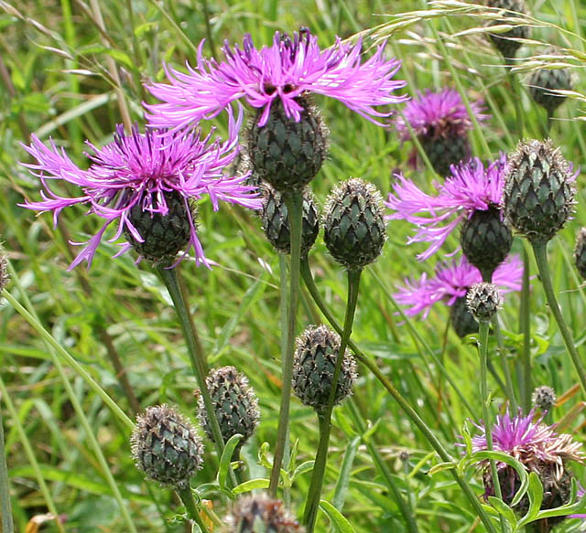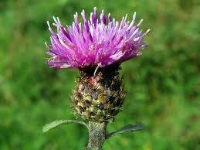

White Campion
Scientific name: Silene latifolia

White campion is a common wildflower that grows in fields, hedgerows, and roadside verges. This plant can grow where other plants cannot, and so is often found in barren areas. It flowers from May to October, but actually blooms at night and produces a strong scent, attracting many moths and other pollinators. White campion has white flowers with five petals, each deeply notched and almost divided into two. It has oval leaves and stems that are hairy, growing up to 1 meter. White campion is generally a perennial plant, meaning it comes back again each spring.

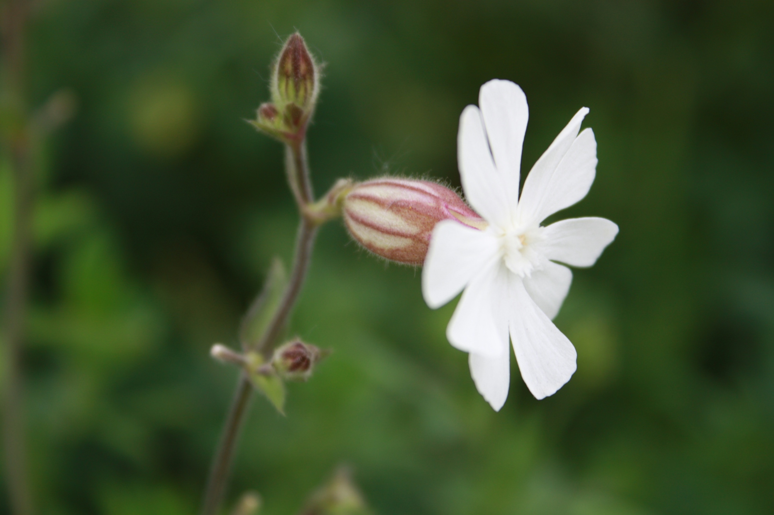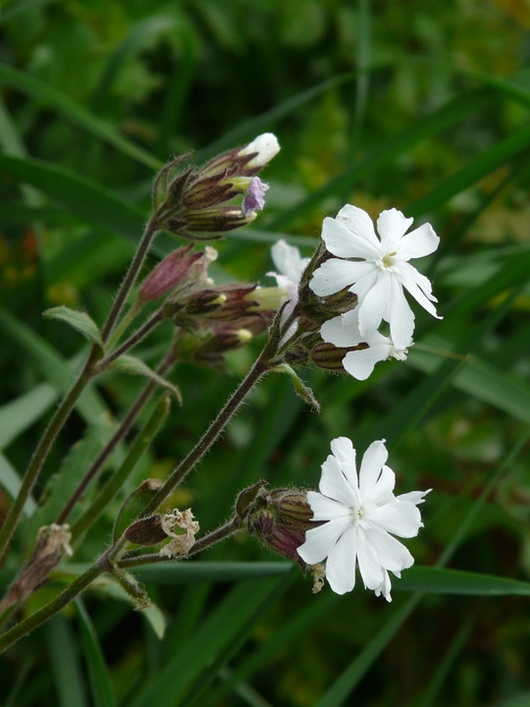

Cornflower
Scientific name: Centaurea cyanus

Cornflowers are found in gardens, meadows, roadsides, and farmlands. It flowers from June to August and grows up to 80cm. The bright blue flowers of the Cornflower are actually composite heads of small flowers (also called florets). In the Cornflower, the outer florets are longer and pointy, and smaller, more purplish flowers are found in the middle. Stems and leaves are long and pointy as well, with hairy, blackish buds at the tips. Cornflowers attract many pollinators, especially bumble bees.

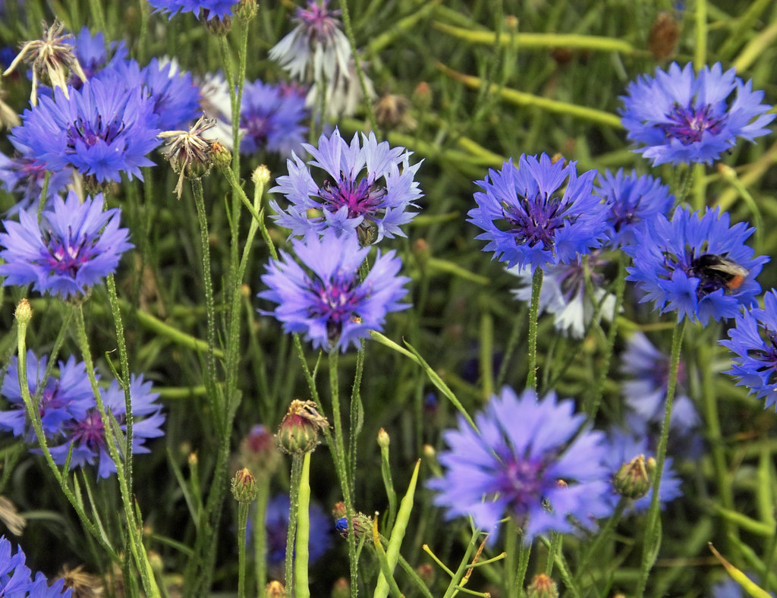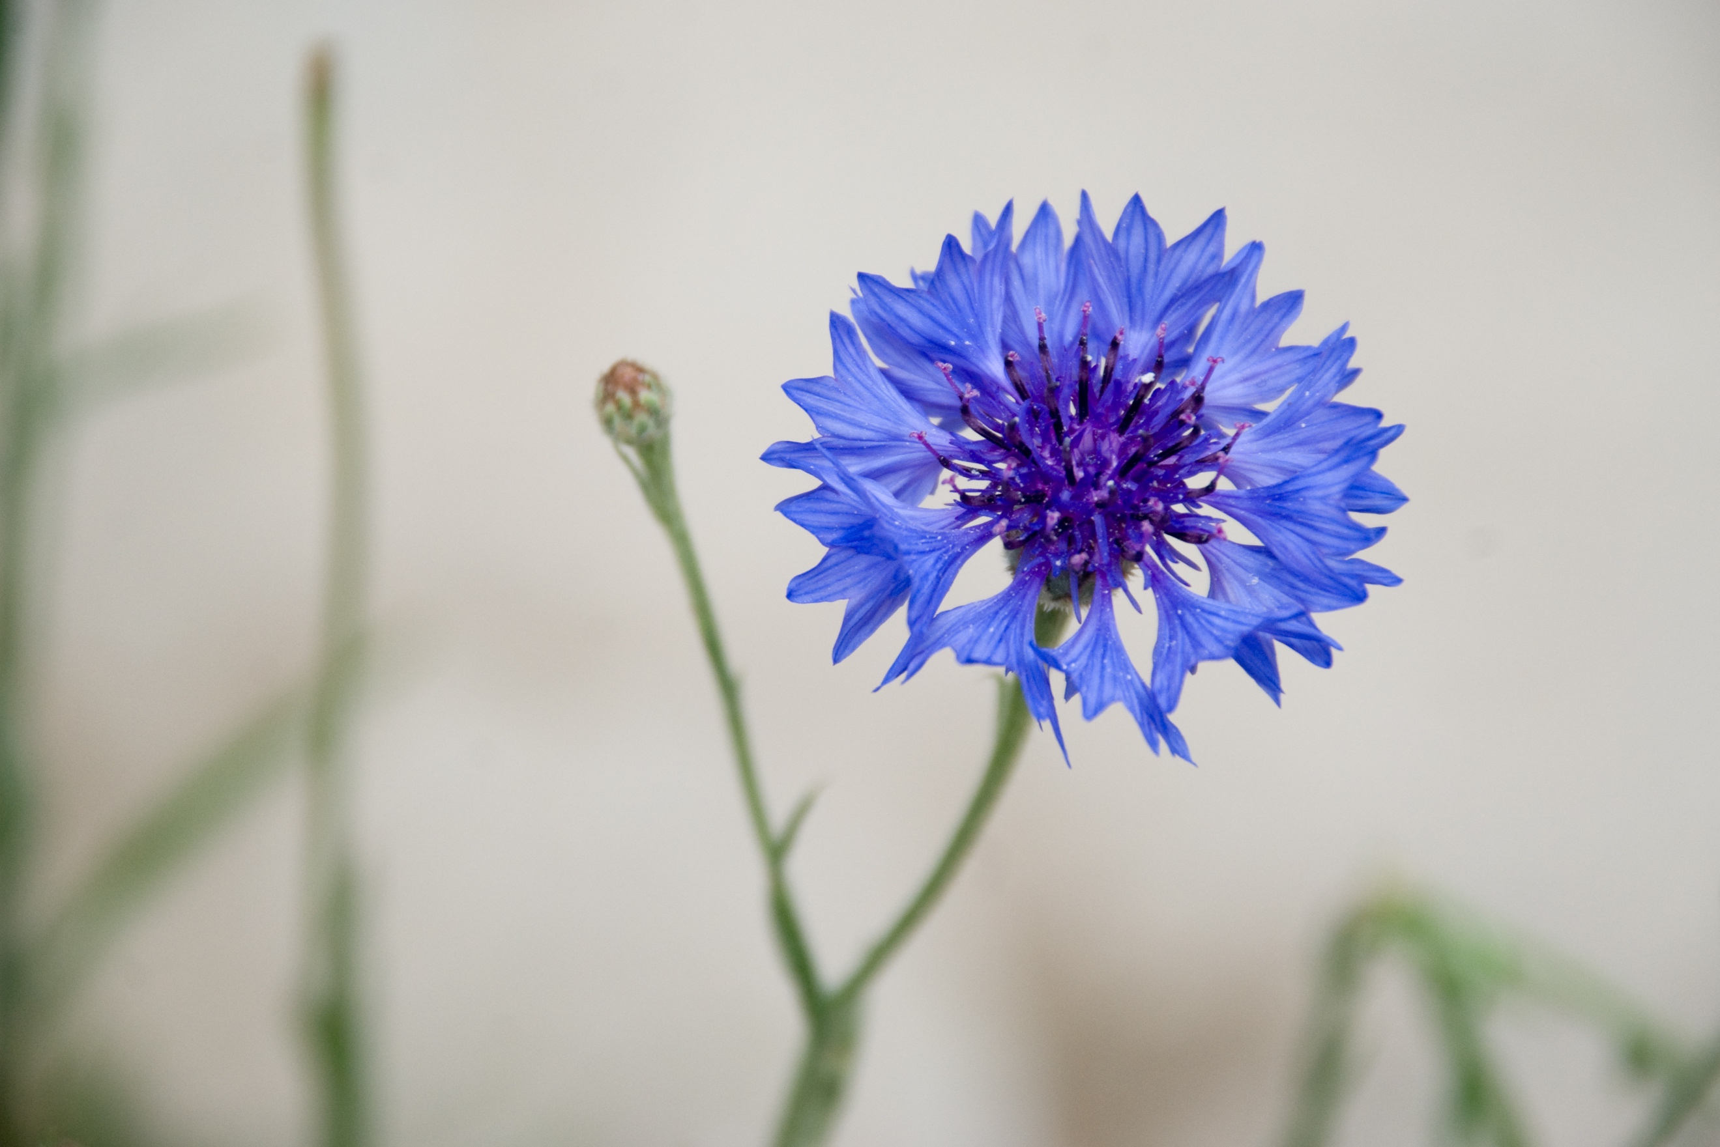

White Clover
Scientific name: Trifolium repens

White clover is a very common plant of all kinds of grassy areas in the UK, including lawns, pastures, roadsides, and meadows. Most white clover plants have the familiar look of three green leaflets, often with white markings. The white flowers have rounded heads, and can sometimes appear pinkish, and bloom from May to October. White clover plants can grow up to 40cm. White clovers provide food for many pollinators, especially bumble bees and butterflies.

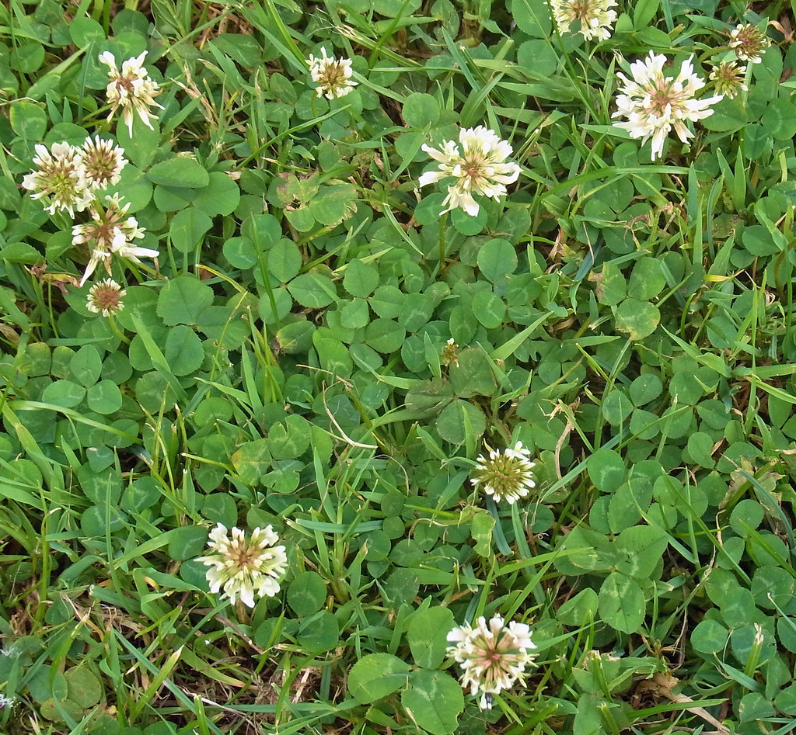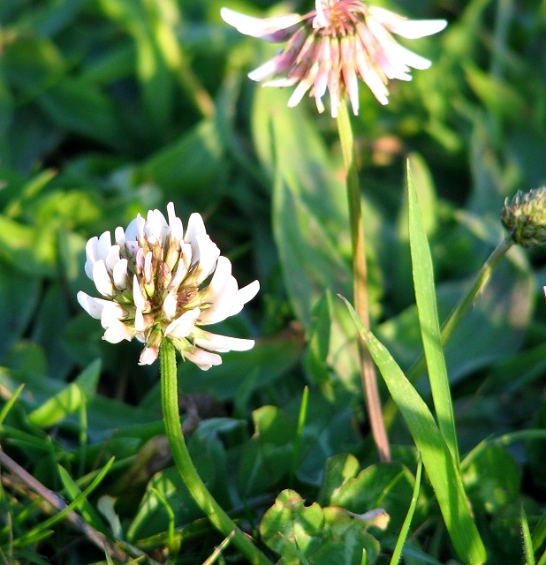

Bluebell
Scientific Name: Hyacynthides non-scripta

The Bluebell grows near woodlands and in towns are gardens. It spends most of the year as a bulb underground in woodland areas, and starts to emerge to flower in April. Bluebells attract the attention of many pollinating insects. The Bluebell is one of the UK’s most famous flowers. It has long, narrow, drooping leaf fronds, and bending flower stems that are heavy with nodding bell-shaped flowers and grows up to 50cm. Millions of bulbs may exist in a woodland area, causing the blue carpets many associate with spring. New bluebell plants can sometimes split off from older bulbs and grow as identical plants.

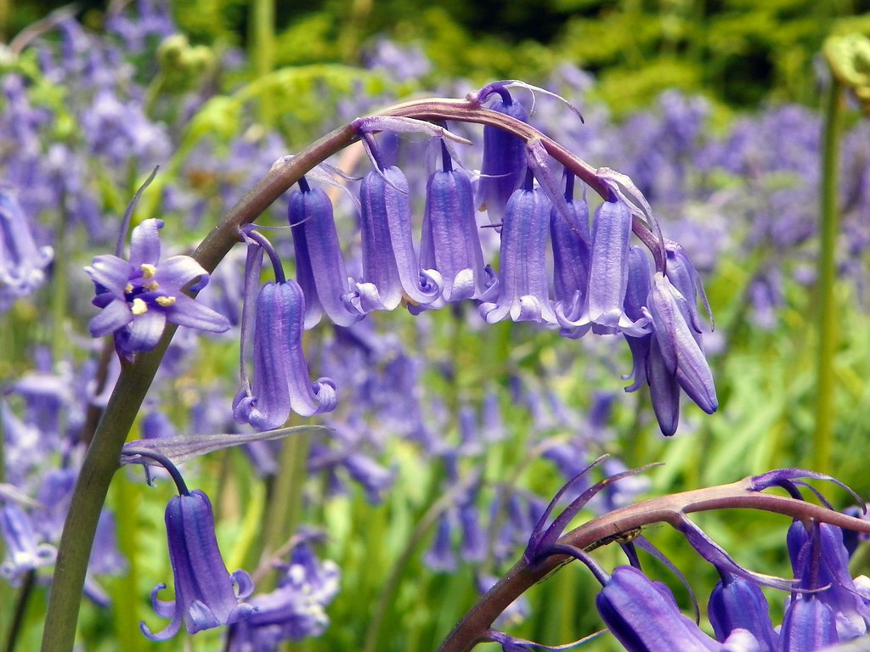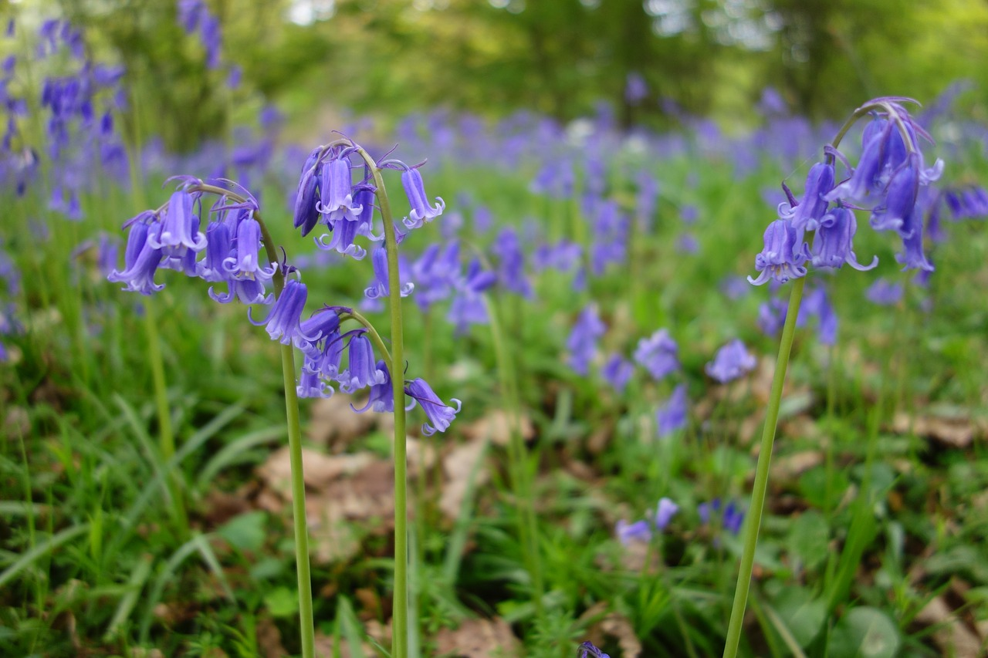

Dandelion
Scientific name: Taraxacum officinale

Dandelions grow in all kinds of grasslands such as lawns, roadside verges, pastures, meadows, and can often be considered a weed. Dandelions have yellow flower heads displaying closely packed tiny flowers, or florets. The leaves of the Common Dandelion are lobed and spoon-shaped. If the stem is broken, a milky white sap will come out. When the plant is ready to seed, the seeds appear white and fluffy and form a spherical, packed seed head. The seeds blow easily in the wind. Dandelions can grow up to 35cm, and can be seen almost all year round, making them an important food source for pollinators. Blooms most often occur between April and October.

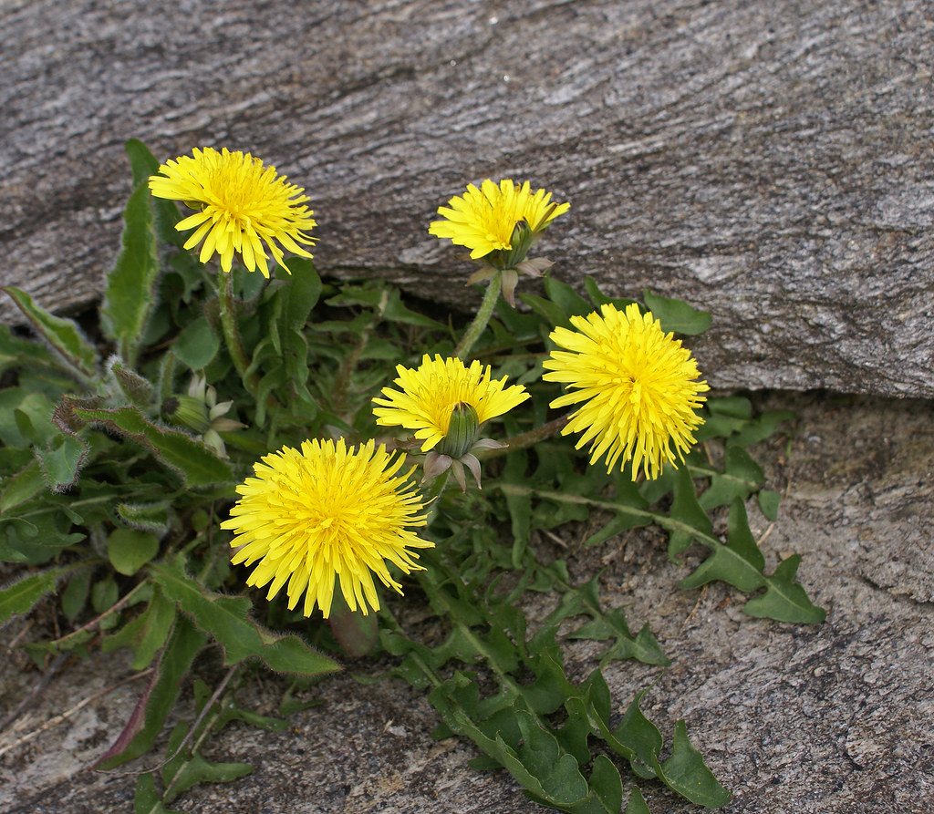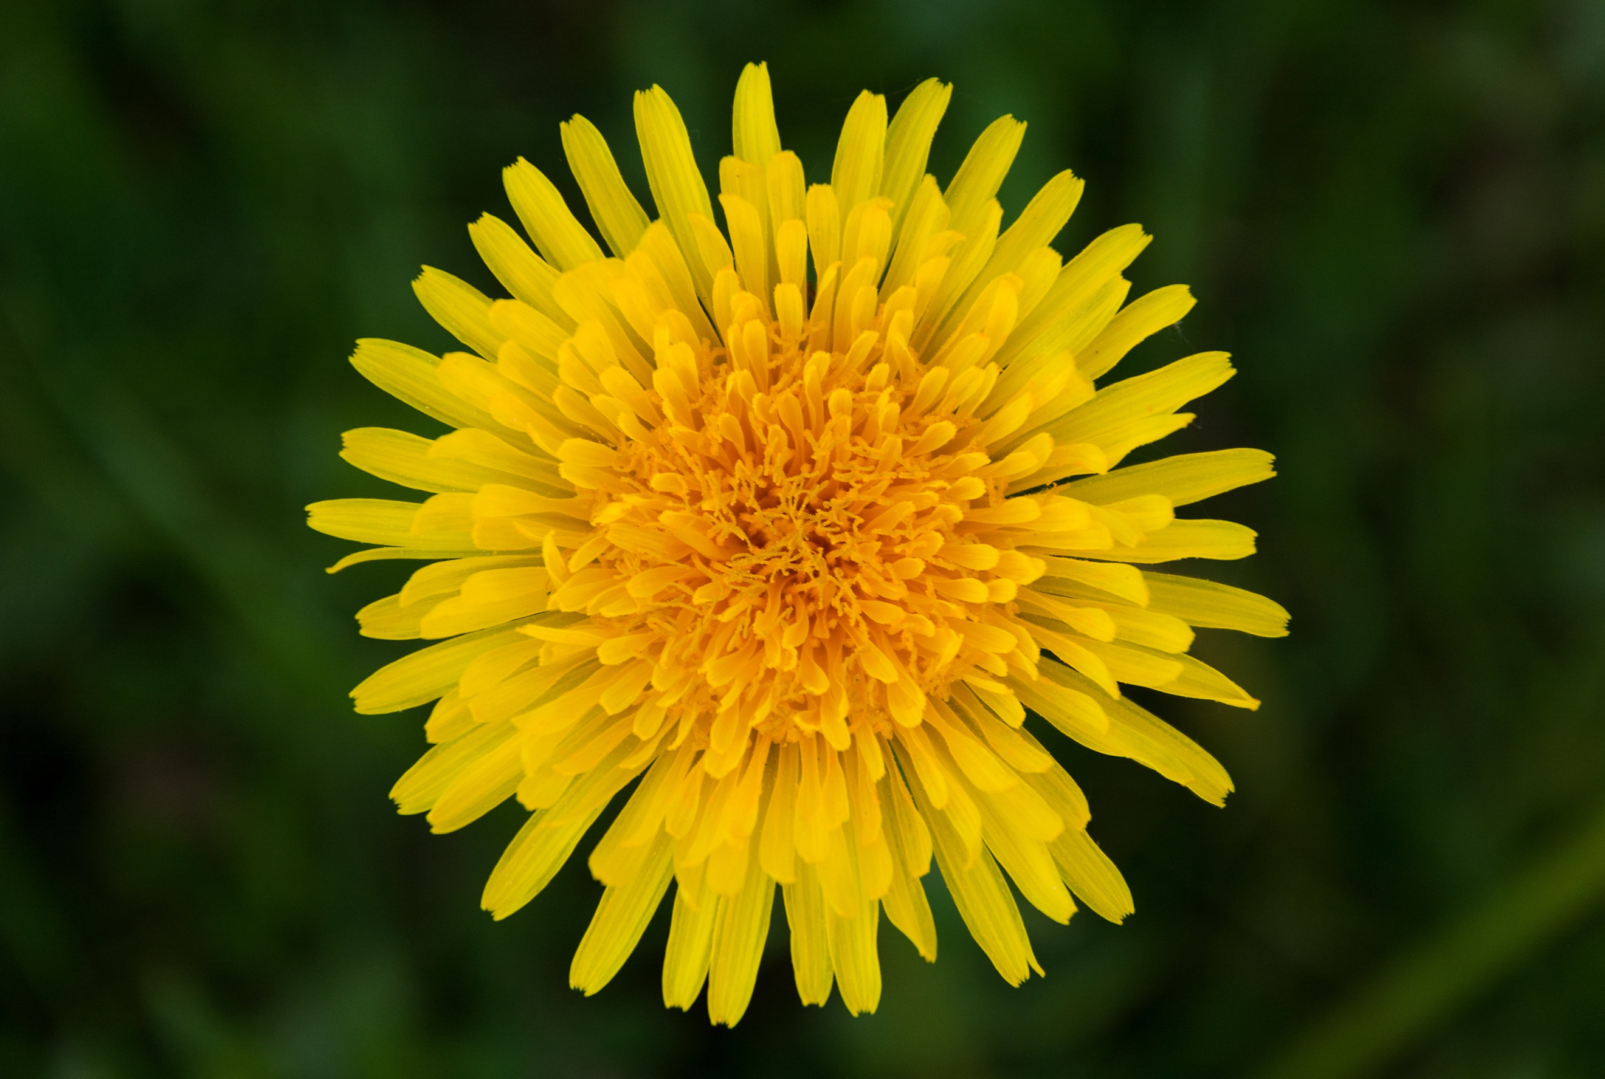
Corn Poppy
Scientific name: Papava rhoeas

Corn poppies grow in grassy areas such as farm fields and meadows. The basic flower has scarlet, single flowers, each petal often marked at its base with a black blotch, growing up to 90cm. The deep red flowers bloom mid-summer and like growing in full sun. Corn poppies grown well with other corn flowers (included in this mix). Flowers are generally a bright red, however can appear paler depending on growing conditions. The poppy is well known as a symbol for fallen soldiers after World War 1.

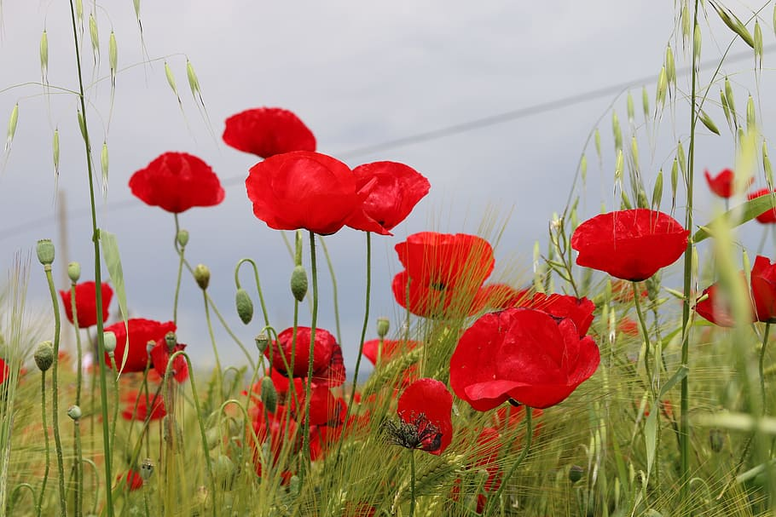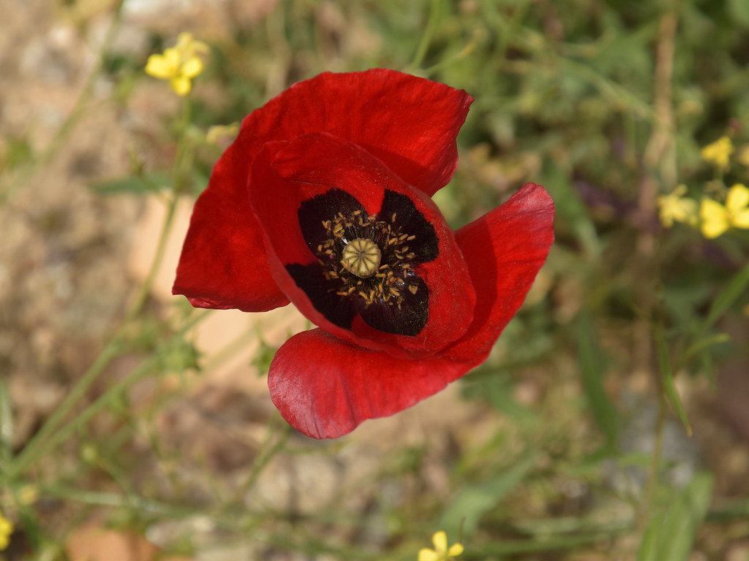

Corn Chamomile
Scientific name: Tripleurospermum inodorum

Corn chamomile is an annual that grows up to 30cm and can be found in grassy areas, such as farmland, meadows, and gardens. Leaves are divided and feathery, with hairy undersides. It flowers June- August, and the flower heads have broad, white florets and central discs of yellow, similar to a daisy.

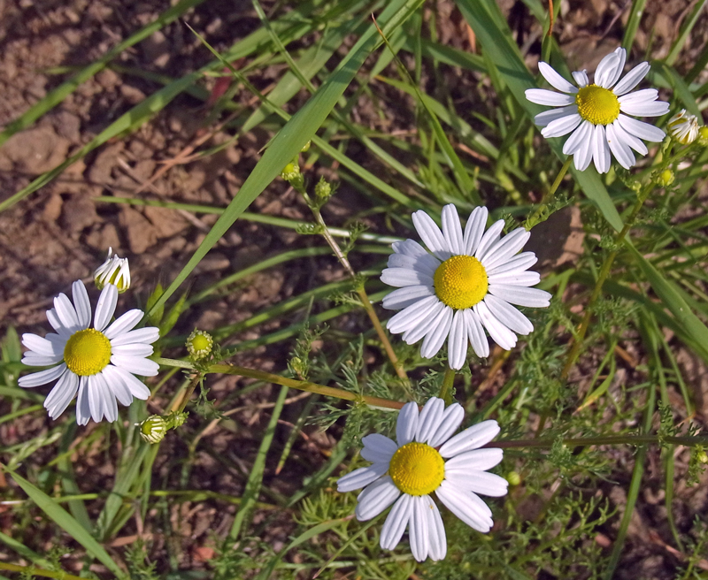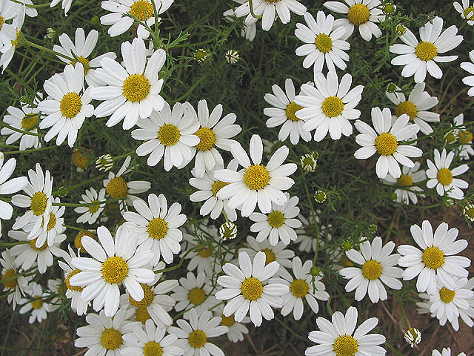

Corn Marigold
Scientific name: Glebionis segetum

Corn marigolds are found in grassy areas, such as farmland, meadows, and road verges. Corn marigolds grow up to 1 m. The flowers are golden-yellow discs with prominent ray florets. The leaves are deeply toothed, hairless and covered with a waxy layer that gives them a greenish blue-grey colour. Corn marigolds bloom from June to October and attract bees, butterflies and moths.

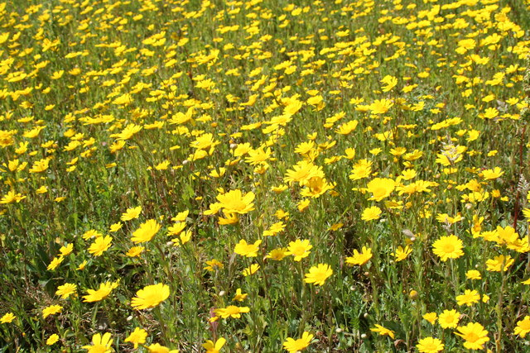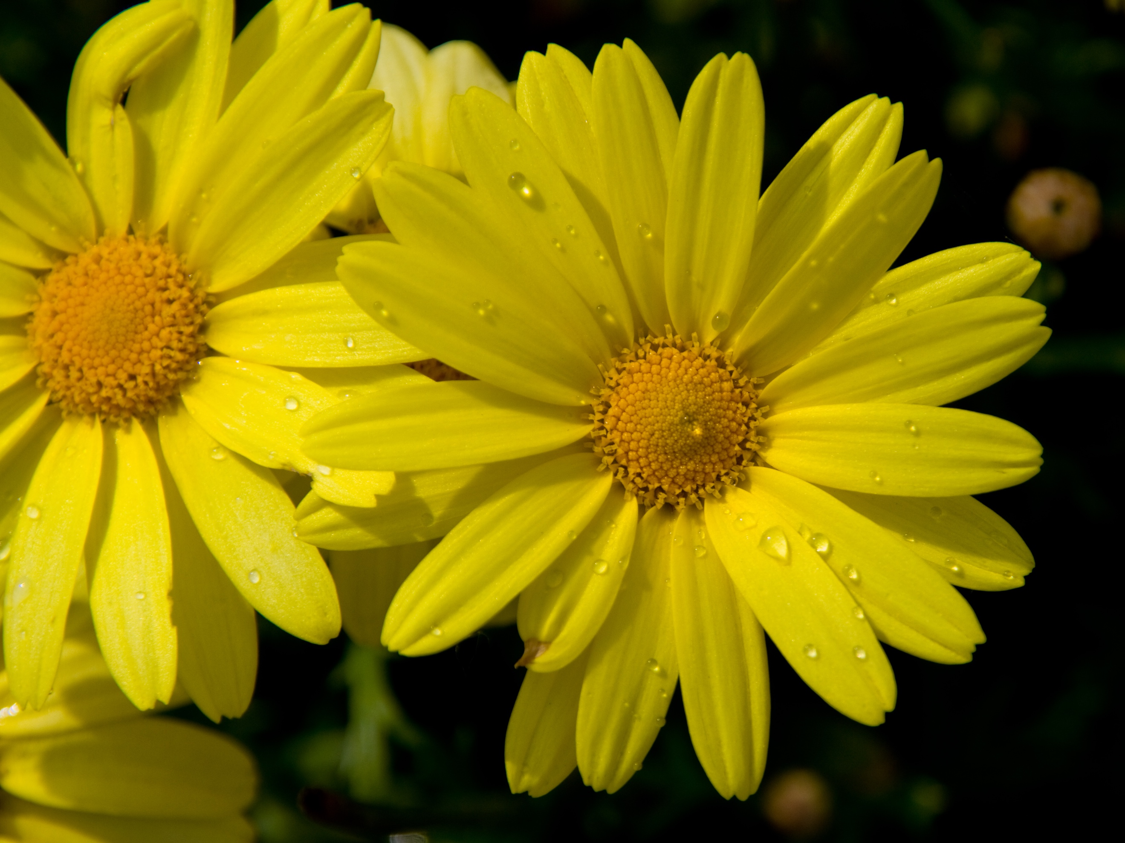

Oxeye Daisy
Scientific name: Leucanthemum vulgare

Oxeye daisies grow in a variety of areas including meadows, fields, forests in disturbed areas. The flower is similar looking to the daisy but has larger flower heads, which can be 6 cm across. The base leaves are spoon-shaped and about 10 cm long. The stem leaves are toothed and more oblong. The plant can grow up to 1 m. Flowers bloom between June and August, and attract many pollinator species.

