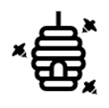
Magnifying Art
At Home Activity
Developed by local artist Nick Davies

For this activity you will need:
- Paper
- Scissors
- Colouring materials (such as crayons or markers)
- Printed out circle template (below)

For this activity, we recommend that you sit in your garden, or outdoor area. Have an adult help you cut out the circle in the template below. You should now have a circular hole in your paper. Use this as your “magnifying glass” and look around the garden. What flowers, insects, and other things can you see through your magnifying glass? Pick an area and set the magnifying glass down onto your chosen area. Draw what you see in the circle using colour. Repeat with another area and compare your drawings. What images did you capture? Can you identify any flowers or insects in your drawing? Come back to the same area in a few days and draw what you see. How does it compare to the first drawing?

Here’s an example:

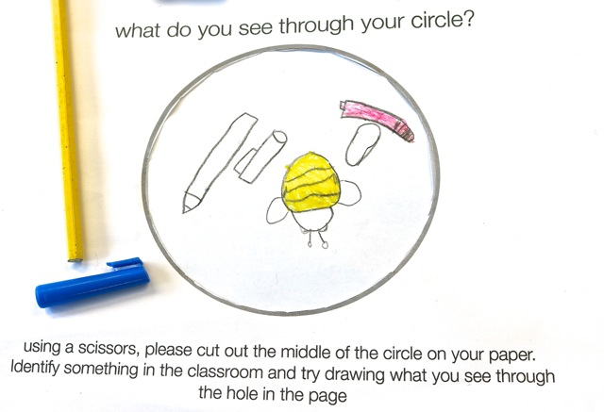

Share your artwork with us @pharambees and @nick1967_nick

For more beautiful artwork by Nick please see:
www.nickdaviesart.co.uk
https://www.makersguildinwales.org.uk/standing-still.html

What do you see through your magnifying glass?

Using scissors cut along the circle. Identify an area you would like a closer look at. Place the circle over the area and draw what you see through the hole.

