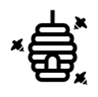
Build A Bee
At Home Activities

Supplies:
- Yellow clay
- Black clay
- White Clay
- Paper and pencil

Let’s make a bee! Use the materials to make a bee in groups of 2-4. Remember the parts of a bee we just learned; how will your bee collect nectar and pollen? You have 5 minutes to build your bee. At the end of the 5 minutes, the class will display their bees. Vote on your favourite bee and share the winner with @pharmabees.
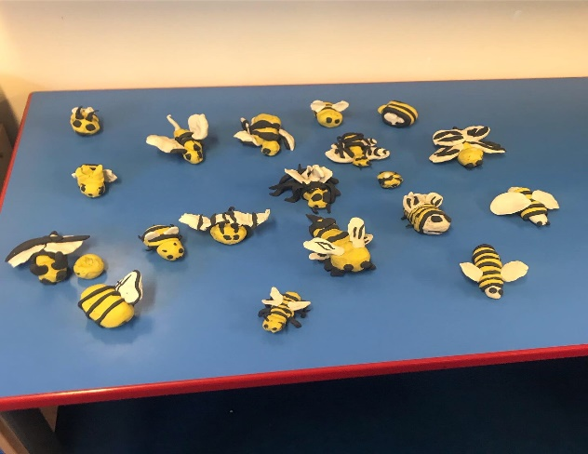
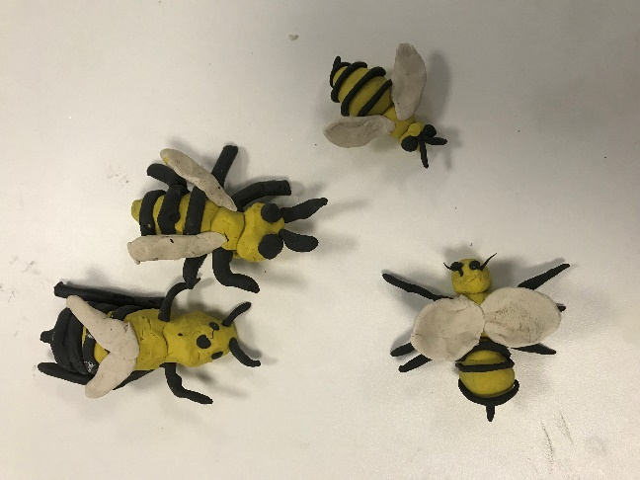

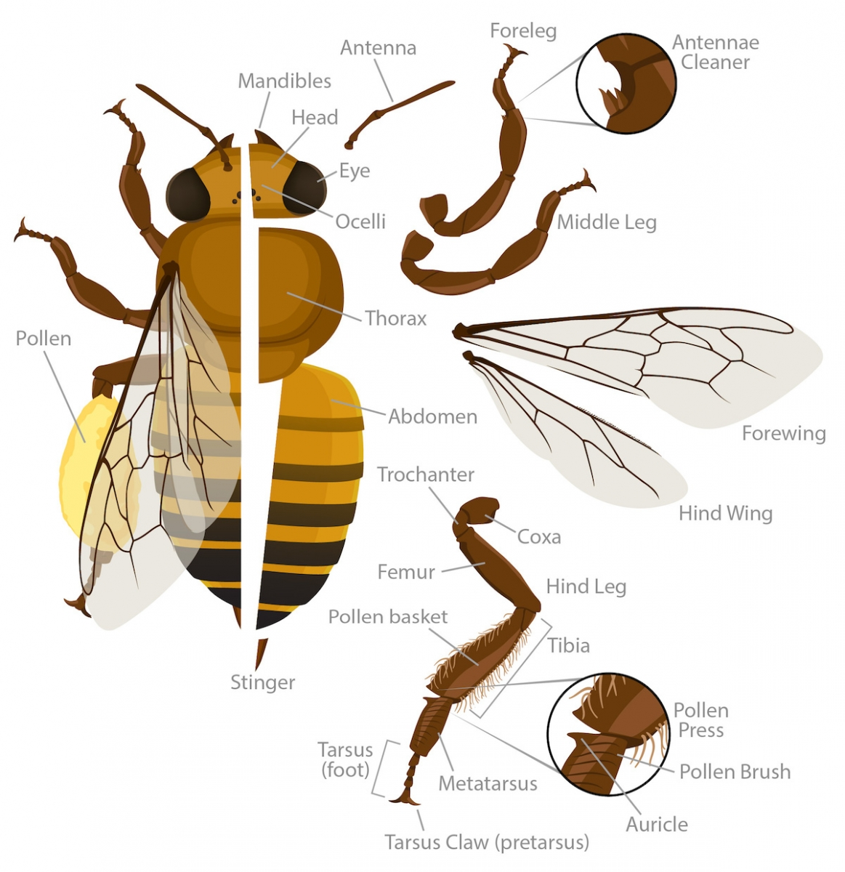
Build A Bee 2:
Now that you have learned more about bees and pollination, build another bee using materials around the classroom. What materials will us use? How will your bee pollinate and travel around?
Feeling crafty? Try an origami bee: https://www.origami-resource-center.com/easy-origami-bee.html

Find out more about bee anatomy:
https://askabiologist.asu.edu/honey-bee-anatomy

