Pharmabee BioBlitz
Weekly Survey

Thank you for taking part in the Pharmabees BioBlitz! This information will help to support biodiversity in South Wales. After you have planted your Pharmabees wildflower mix, we need your help to monitor growth over time and record data. Please use this sheet weekly to monitor your growing space for wildflowers and insects. Don’t forget to include your seed packet number, which is the number at the top of your seed packet. Remember not to include any personal information on this sheet. After your survey, have an adult help you submit the results online to: https://cardiff.onlinesurveys.ac.uk/pharmabees-bioblitz-survey
Remember to take a photo of any bees you see! Record your pollinators and plants to Spot A Bee website: http://spotabee.buzz/
Share photos of your beautiful growing spaces with us @pharmabees

Pollinator ID help:
https://sciencesessions.wixsite.com/sciencesessions/pollinator-id
http://www.bloomsforbees.co.uk/id-guide/
https://www.bumblebeeconservation.org/identify-a-bumblebee/
http://legacy.discoverwildlife.com/sites/default/files/pdf/BBC%20Wildlife%20Magazine%20British%20pollinators%20poster.pdf
https://www.opalexplorenature.org/sites/default/files/7/image/Pollination%20chart%2026Feb16%20low%20res%20web%20quality_0.pdf

Find out more about wildflower species:
https://www.wildlifetrusts.org/wildlife-explorer/wildflowers
https://www.plantlife.org.uk/uk/discover-wild-plants-nature/plant-fungi-species
https://www.rhs.org.uk/plants/search-form

For more information on how to identify common weeds: https://www.rhs.org.uk/advice/common-weeds
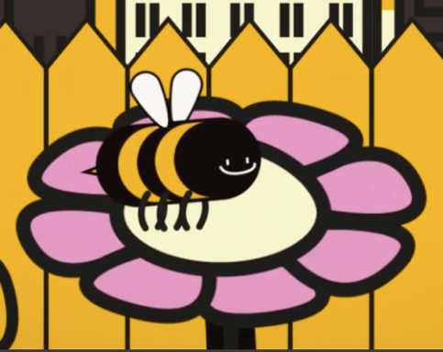

The data you collect as part of this project must be submitted by an adult (aged 18 years or older). The adult may be a parent, guardian or teacher. Do not submit any personal information.
https://cardiff.onlinesurveys.ac.uk/pharmabees-bioblitz-plant-and-pollinator-survey
Seed Packet Reference Number:…………………….
Date: .......................... Time: ............................
Site Location: (ie Cathays)……………………………….
Planting Date:……………………….. Weeks since planted: ……………………………………..
Which habitat are you looking at? (Please circle)
Plants in Pot Plants in Ground

Amount of Flower cover (Please circle one):
- Flowers occupy less than half of patch
- Occupy half
- Occupy more than half of patch
- Just seedlings (no bloom yet)
How many total flowers do you see? (see plant ID sheet):

Which flower species are you surveying? Please mark how many of each you see
Common Knapweed: |  | Corn Flower:
Corn Chamomile: |  | White Clover:
Bluebell: |  | Corn Marigold:
Oxeye Daisy: |  | White Campion:
Dandelion: |  | Corn Poppy:

Other flowers observed:
The Weather (please circle):
- Full sun
- Sunny intervals
- Total cloud
- Other (please explain)

How has the weather been this week?

What is the wind like today? (Look at the movement of leaves on trees) (please circle):
- Leaves moving gently all the time
- Leaves moving strongly
- Leaves still/moving occasionally

Precipitation (please circle):
- Rain
- No rain

How many days this week has it rained?

What is the temperature?
(Check a thermometer or google weather)

What is the average temperature for this week?

How many insects did you see?
Please tally up the number of each sort of insect that you see when looking at the flowers in your patch for 10 minutes. Try to avoid casting a shadow over the patch as this may scare off insects. Try not to record the same individual twice.
Honeybee: |  | Tawny Mining Bee:
Red Mason Bee: |  | Buff Tailed Bumblebee:
White Tailed Bumblebee: |  | Tree Bumblebee:
Common Carder Bee: |  | Garden Bumblebee:
Red Tailed Bumblebee: |  | Early Bumblebee:

Which other insects did you see?

