Where Does Bacteria Grow?

At Home Activities

Bacteria Swab:
Supplies:
- Cotton buds
- Potato slices
- Container
- Marker for labelling

Think of an item or area in the room or household you would like to swab. Make a hypothesis regarding which item/area will have the most bacteria. Think about which areas people touch the most, and would have the most exposure to germs. Draw a map of your home, using the example below as a guide. Give each location/item you choose to swab a number so that you can relate your results to a particular site for example: toilet seat (1), table top (2), door handle (3). Mark the locations on your map with the number.

Have an adult prepare the potato slices using the instructions below. Each child should have a potato slice and cotton bud. Remember that it is important to start with a clean cotton bud. If the cotton bud has been previously used or is dirty, the experiment will not work. Be sure not to touch the ends of the cotton bud before the experiment. Swab the item/area for a few seconds, and then immediately swab the potato slice for a few seconds. Close the container immediately after swabbing and label the potato slices.
Let the containers incubate in a warm, dark place such as a cupboard. Check growth after 24 hours. Some bacteria may have started growing. Check again in 48 hours and compare the difference. You should see bacterial growth within a few days.
Plot the results of where the bacteria are growing on the map you created. Which spots in the have a lot of germs? Discuss why some spots may have more bacteria then others, and the importance of sanitation. Which areas would you swab next, and why?
Optional: Make a hypothesis about which place will be best for growing bacteria. Place some containers in the light (such as by a window), some in a cool area (such as a refrigerator), some in a warm area (by the heater), and some in the dark (such as a closed drawer). Check the growth from all areas each day and compare results.
Demo Video: https://www.youtube.com/watch?v=H5hwG9f9pL4

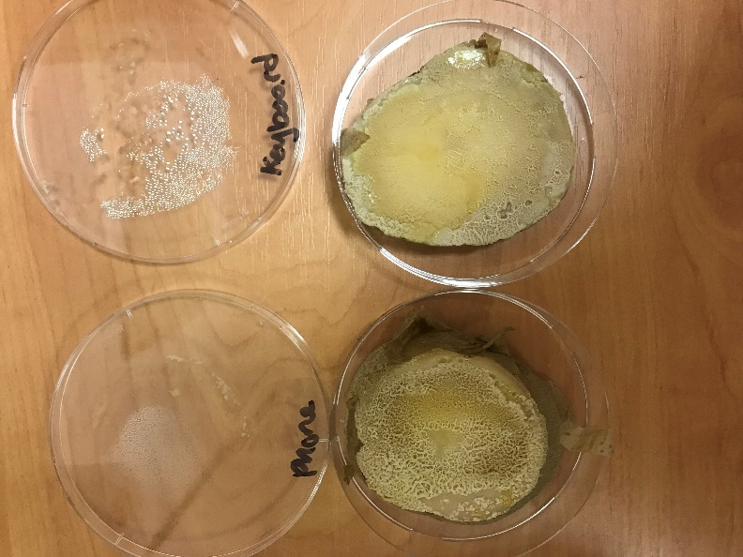
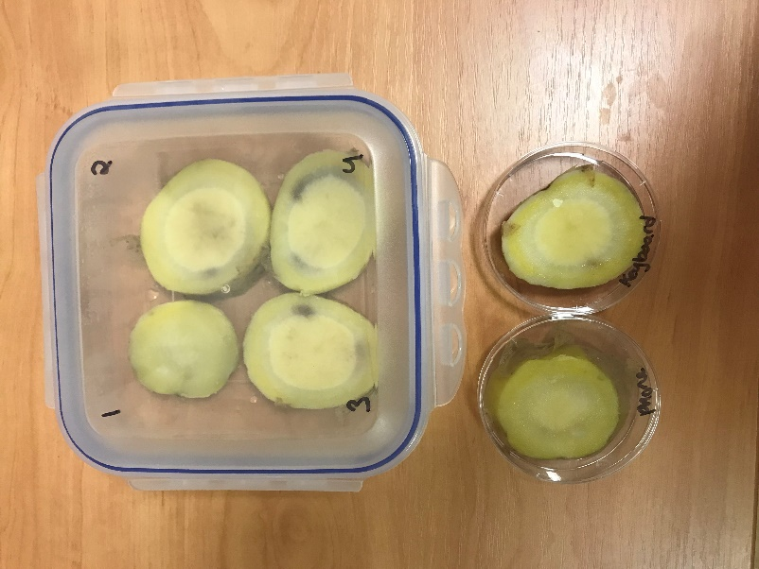

Prepared potatoes before swabbing Potatoes 48 hours after swabbing

Potato preparation:
Supplies:
- Potatoes
- Knife
- Cutting board
- Clear container

Adult supervision is required for the preparation. Prepare the potato to grow the bacteria on. Carefully clean one or two large potatoes. Boil potato for 10 mins to sterilise the potato. While the potato is boiling, get a clear lunch container or jar, and clean. Sanitise the container with boiling water. Also sanitise the knife and cutting board with boiling water. After the potato has boiled, drain and let cool. Slice the potato into 1cm slices and place into container. Keep container sealed until the swabbing activity. Be sure to let the potatoes cool completely before starting the experiment.
If there are enough containers for each child, place one potato slice in each container. Otherwise, place the slices into one container. The slices should lay flat and not be stacked. The lid should be clear so that children can see the bacteria growth on the potato slice without having to open the container. Remember to mark the container to record where you swabbed for each potato slice (eg. phone, keyboard, etc).
Demo Video: https://www.youtube.com/watch?v=lPv1gspW4l4
Why can’t I see any results?
After preparing the potatoes, it is crucial that the potatoes completely cool before swabbing. If the potatoes are still hot, then the bacteria will not grow and will be killed. If the potato is still warm, it will also create a lot of moisture in the container due to condensation. Too much water will inhibit bacterial growth.
Did you swab something dusty? If you swabbed something very dusty, you may not see results. Dust is comprised of small particles and dead cells and bacteria, meaning that they will not grow on a potato. Although the area looks dirty (and likely is) you need to swab an area with living bacteria to see results.
You will only see bacteria on your potato, and possibly fungi. Fungi will look like wispy strands (like spun sugar/cotton candy). You will not be able to grow viruses on your potato. This is because viruses need a living host, and very specific growing requirements. A potato slice will not support viral growth. This is an advanced biology topic, and if you would like to learn more see:
http://simulab.ltt.com.au/4/laboratory/personalstudy/psVirusCulture.htm

Rules for working with bacteria:
- Never eat or drink near your cultures, be sure to wash your hands after working with cultures at the end of class.
- Keep the lids on your cultures and remove only briefly as needed.
- Wash your hands immediately after working with bacterial cultures.
- Sanitise the work surface you are using before and after working with bacteria.
- When you have finished with your cultures, clean the container well, and throw away the potato slice. An easy way to clean is to pour in a little bleach into the container with the potato to kill all bacteria, dispose of the potato, and then clean the container.

Resources:
Bacteria Overview:
https://microbiologyonline.org/about-microbiology/introducing-microbes/bacteria
https://www.natgeokids.com/uk/primary-resource/bacteria-primary-resource/

Microorganisms:
https://www.bbc.co.uk/bitesize/topics/zfxxsbk

Food Poisoning and how bacteria grow:
https://www.safefood.eu/Food-safety/Food-Poisoning.aspx

How long can bacteria and viruses live outside the body:
https://www.nhs.uk/common-health-questions/infections/how-long-do-bacteria-and-viruses-live-outside-the-body/

Different types of germs:
https://askabiologist.asu.edu/explore/puzzling-pathogens

Calculate how quickly bacteria can grow:
https://www.bbc.co.uk/bitesize/guides/z243g82/revision/2

Brief Video Introduction to Microbiolgy:
https://www.youtube.com/watch?v=WlGQaVgfpmw&t=82s

For more information on fungi see:
https://microbiologysociety.org/why-microbiology-matters/what-is-microbiology/fungi.html
https://www.khanacademy.org/science/biology/crash-course-bio-ecology/crash-course-biology-science/v/crash-course-biology-138

