Thirsty Plants

Water Activity

Water is very important to plants, and humans. Plants need water to grow and to produce food. Plants make their own food through a complex, sunlight-powered process called photosynthesis. To learn more about photosynthesis, see: https://www.bbc.co.uk/bitesize/guides/zpwmxnb/revision/1
To learn more about the water cycle, see: https://www.bbc.co.uk/bitesize/guides/z4bk7ty/revision/1
In photosynthesis, water (absorbed by roots from the soil) and carbon dioxide (taken from the air by leaves) combine to make the plant’s energy. Water also helps transport nutrients throughout all parts of the plant. Water also helps support the plant by filling up the cells that make up the plant so that it can stand up straight. We call this rigidity. Water is crucial to a plant’s life, so a plant will die quickly without water.
Water travels through the plant in long, thin tubes running up from the roots to the stems and leaves. These tubes are called the xylem. Water moves up the xylem through a process called capillary action. Capillary action allows water to be pulled through the thin tubes because the molecules of the water are attracted to the molecules that make up the tube. The water molecules at the top are pulled up the tube and the water molecules below them are pulled along because of their attraction to the water molecules above them. (Think of positive and negative charges, like magnets).
To get rid of excess water, plants use a process called transpiration. During transpiration, water evaporates from holes in the surfaces of leaves into the air. As water molecules evaporate from plant leaves, they attract the water molecules still in the plant, helping to pull water up through the stems from the roots. The combination of transpiration and capillary action delivers the water from the bottom to the top of a plant. Water can travel a long way through plants, imagine a redwood tree which can reach heights of 115m with root systems up to 30m.
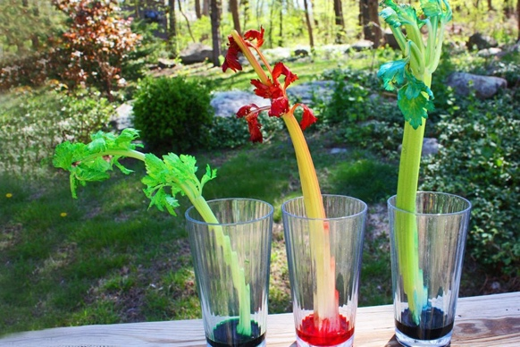
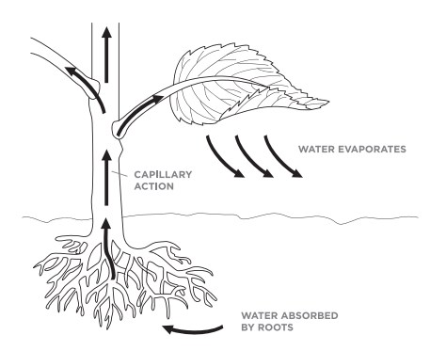

Supplies:
- Clear jars
- Water
- Food colouring
- Celery
- White Carnations

Experiment:
Fill the cup about three-quarters of the way to the top with water. Add 5-10 drops of blue or red food colouring until the colour of the water is dark. Stir the colouring in. Cut about 2.5 cm off the bottom of the stalk of celery with the knife and place the celery into the cup with the leaves sticking up, and the bottom in the coloured water. Check the stalk several times throughout the day. Observe how the leaves are changing. Let the stalk sit overnight. Look for small circles at the bottom of the stalk that are the colour of the dye you used. (These circles are xylem, the tubes that carry water up the plant.) If you can’t see them, try cutting off 1 cm from the bottom of the plant.
Demo Video: https://www.youtube.com/watch?v=bDIYhNnqqK8

Part 2:
Take a bouquet of white carnations. Add different colours of food colouring to different jars. Carefully cut the bottom of the stem of the carnation 1 cm. Place one or two carnations in each jar. Observe the carnations every hour or so, and watch as the flowers slowly changes colour. Leave overnight and come back to find a rainbow or carnations. See if you can see the xylem tubes at the bottom of the stems.
