The Jar Test

Soil Texture Activity

Soil is made of physical, biological, and chemical components. How these components interact with each other will determine a soil's characteristics. Soil is comprised of soil particles, organic matter, water, air and living organisms. These are all important to the overall health of the soil and to the plants that grow in it. The three primary soil particles are sand, silt, and clay. The relative percentages of these components present make up the soil’s texture. Texture is important to overall soil and plant health as it relates to soil porosity, which refers to the pore spaces where air and water reside.
The solid components of soil include minerals, organic matter, and organisms living in the soil (also known as biota). Pores in the soil can be filled with water, air, and biota. Healthy soils consist of a range of pore sizes, from small to large. Mineral composition includes sand, silt, and clay and it is the proportion of these components that is used to classify soil. Although only a small portion of soil consists of the living organisms in biota, it is estimated that there are more species of organisms in a shovel of soil than above ground in the entire Amazon rain forest (NRCS). Biota play a significant role in soil health as soil food webs influence soil functioning.
The ideal soil texture is a mix of sand, silt, and clay particles, known as a loam. In most cases the particles will not be balanced, and the soil will need to be altered by adding organic amendments. To evaluate soil texture, use a simple jar test to determine the percentages of sand silt, and clay. Once the percentages have been calculated, the soil textural triangle can be used to determine the soil type.

Materials:
- clear glass jar (such as Kilner or mason jar)
- Permanent marker
- Ruler
- Timer
- 1 tablespoon dishwasher powder (powdered detergent such as finish)
- Mesh sieve (can also use a colander)

Take a soil sample from your desired planting area. Use a garden spade, or small hand trowel to dig into the ground. Soil should be sampled to root depth, which typically means 13-20cm (5 to 8 inches) for flowerbeds and vegetable gardens. Remove any organic material. Organic matter and plants on top of the soil should not be included in soil test samples, as it can affect the soil test results. Using a mesh sieve or colander, sift the soil to remove any debris, rocks, and large organic matter (leaves, sticks, roots, etc.).

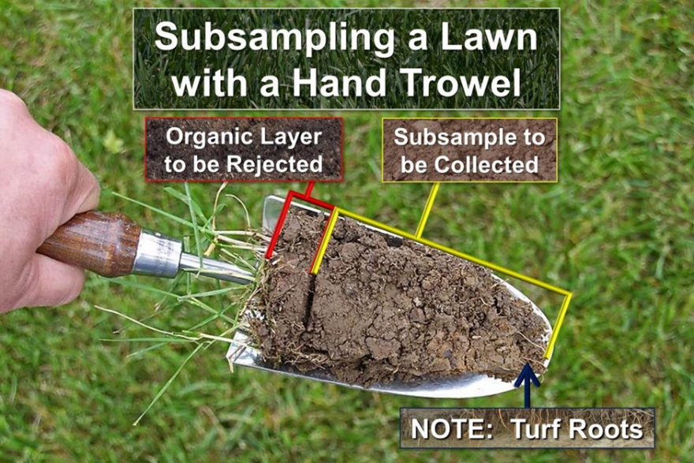

Using a hand trowel for soil sampling. Photo by Joe Boggs, Ohio State University Extension.

Fill the jar ⅓ with the soil. Add 1 tablespoon of dishwasher powder and fill the remainder of the jar with clean water. Put the lid on the jar and shake vigorously until the soil turns into a uniform slurry. This should take about 3-5 minutes. Play your favourite song while shaking the jar. Pass the jar to your peers for a turn if you get tired. (https://www.youtube.com/watch?v=nfWlot6h_JM)

Set jar on a level surface, such as a windowsill. Leave the jar overnight for the soil layers to settle. If layers have not settled overnight, leave for up to 48 hours. Mark the jar where the coarse sand layer has settled at the bottom of the jar. Mark the next layer, the silt layer. Mark the top of the next settled layer with the permanent marker. This is the clay layer that has settled on top of the silt layer. Using a ruler, measure and record the height of each layer, and the total height of all three layers. Then Use the soil texture triangle to estimate the soil type for the site.
Demo Video: https://www.youtube.com/watch?v=x1hu6Bo1M74

The clay percentages are listed on the left side of the triangle. Lines corresponding to clay percentages extend from the percentages reading left to right (see red line). The silt percentage is on the right side, with lines extending downward, diagonally right to left (see green line). The sand percentage is on the right side, with lines extending upward, diagonally right to left (see blue line). Track the lines with the percentages measured and find the spot on the triangle where all three lines intersect. The region where these lines intersect indicates the soil type present. The example shown represents a loam soil texture. (https://hgic.clemson.edu/factsheet/soil-texture-analysis-the-jar-test/)
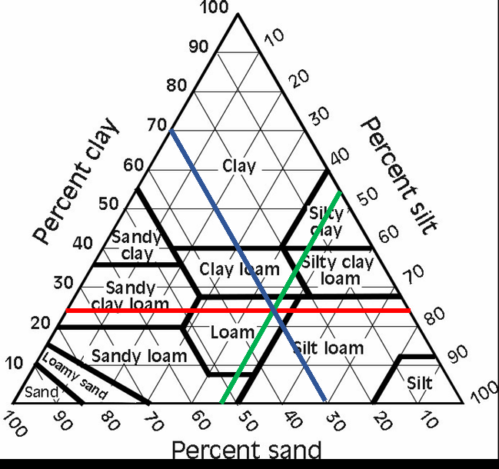

The Jar Test
Soil Texture Activity
Student Worksheet

Take a soil sample from your desired planting area. Use a garden spade, or small hand trowel to dig into the ground. Soil should be sampled to root depth, which typically means 5 to 8 inches (13-20cm) for flowerbeds and vegetable gardens. Remove any organic material, such as grass, sticks, and leaves. Using a mesh sieve, sift the soil to remove any debris, rocks, and large organic matter (leaves, sticks, roots, etc.).
Fill the jar ⅓ with the soil. Add 1 tablespoon of dishwasher powder and fill the remainder of the jar with clean water. Cap the jar and shake vigorously until the soil turns into a uniform slurry (this should take about 3-5 minutes). Play your favourite song while shaking the jar. Pass the jar to your friends for a turn if you get tired.
Set the jar on a level surface, such as a windowsill. Leave the jar overnight for the soil layers to settle. Mark the jar where the coarse sand layer has settled at the bottom of the jar. Mark the next layer, the silt layer. Mark the top of the next settled layer with the permanent marker. This is the clay layer that has settled on top of the silt layer. Using a ruler, measure and record the height of each layer, and the total height of all three layers. Then use the soil texture triangle to estimate the soil type for the site.

Let’s Measure:

Height of sand layer:

Height of silt layer:

Height of clay layer:

Total Height of Layers:

% Sand=(sand height)/(total height) x 100 = % Sand

% Silt=(silt height)/(total height) x 100 = %Silt

% Clay=(clay height)/(total height) x 100 = %Clay
Now that we have our sand, silt, and clay percentages, lets mark the soil texture triangle to find out which soil type we have.
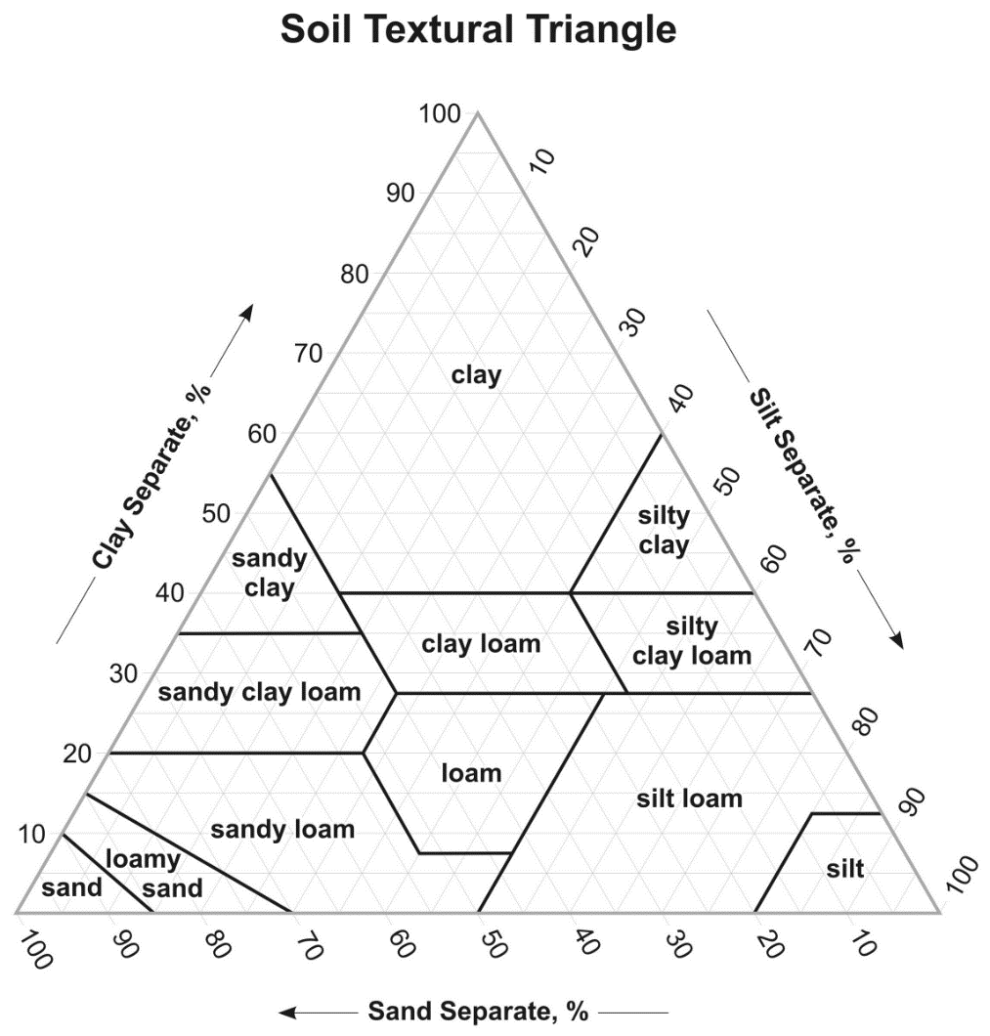

Soil Type:

Find out which plants are good for your soil type: https://www.rhs.org.uk/advice/profile?pid=179

