Handwashing

At Home Activities

Supplies:
• Soap
• Prepared potato slices (see below)
• Sink with running water
• Timer

Washing hands to remove bugs such as viruses and bacteria is an important means of preventing the spread of germs which can make you sick. In this experiment we are checking to see if washing your hands reduces the number of germs present on your hands, by growing germs on potato slices. Get an adult to prepare potato slices in containers, as instructed below.
See the following NHS guidance on handwashing: https://www.nhs.uk/live-well/healthy-body/best-way-to-wash-your-hands/
Make a hypothesis as to what each potato slice will look like before and after you wash your hands and explain the reasons(s) behind your hypothesis.
First, before washing your hands, rub your fingers and hands across the surface of the potato slice. Mark the potato slice as “unwashed hands”. After touching the potato slices, be sure to close the lid of the container.
This will be the control for our experiment. This will show which bacteria are on our hands when we do not wash them. (A scientific control is an experiment or an observation designed to minimise the effects of variables other than the independent variable. This increases the reliability of the results, often through a comparison between control measurements and the other measurements). By having a potato slice without hand washing as a control, we can show how well the soap worked. This will in turn highlight the efficacy of the soaps when it comes to killing bacteria. If the potato slice with unwashed hands shows lots of bacteria, and the soaps do not, we can see how well the soap cleaned our hands.
Wash your hands for 20 seconds using soap and following the NHS handwashing guidelines. Make sure to time how long it takes to wash your hands. After you have washed and dried your hands, touch a new potato slice with your fingers and hands. Close the container immediately afterwards and label potato as “washed hands”.
Let the potato slices in the container(s) incubate in a warm, dark place. This can be in a cupboard, near a radiator, or in a box. Check growth after 24 hours. Some bacteria may have started growing. Check again in 48 hours and compare the difference. You should see bacterial growth within a few days. Compare the results between unwashed and washed hands. You should see a difference in the amount of growth between potato slices, showing that handwashing is an effective way of removing germs from your fingers and fighting infection.

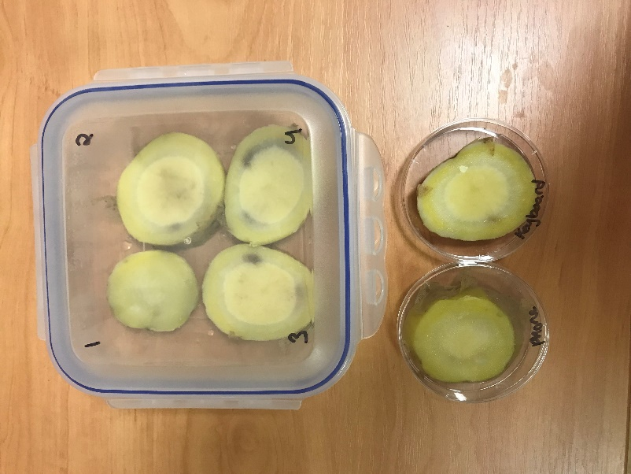

Prepared potatoes before swabbing Potatoes after 48 hours with bacterial growth

Why is it important to wash your hands properly?
DemoVideo: https://www.youtube.com/watch?v=8rGozRYF0wo&t=1s

Important notes:
Make sure everyone washes their hands for the proper amount of time. Provide paper towels or clean towels, so that no one dries their hands on their clothing and picks up bacteria. If working in groups, make sure everyone using soap uses the same amount of soap (liquid soaps are easier to measure pumps). All these tips help ensure consistency of variables which helps to reduce variation in results.
Additional Experiment options:
- Test how the amount of time washing hands affects cleanliness
- Test washing hands with just water vs soap and water
- Test washing hands with cold vs warm water
- Test bar soap vs liquid soap
- Test antibacterial soap vs regular soap

Potato preparation:
Supplies:
- Potatoes
- Knife
- Cutting board
- Clear container

Adult supervision is required for the preparation. Prepare the potato to grow the bacteria on. Carefully clean one or two large potatoes. Boil potato for 10 mins to sterilise the potato. While the potato is boiling, get a clear lunch container or jar, and clean. Sanitise the container with boiling water. Also sanitise the knife and cutting board with boiling water. After the potato has boiled, drain and let cool. Slice the potato in 1cm slices and place into container. Keep container sealed until the swabbing activity. Be sure to let the potatoes cool completely before starting the experiment.
If there are enough containers for each child, place one potato slice in each container. Otherwise, place the slices into one container. The slices should be laid flat and not be stacked. The lid should be clear so that children can see the bacteria growth on the potato slice without having to open the container. Remember to mark the container to record the area you swabbed for each potato slice (eg. phone, keyboard, etc).
Demo Video: https://www.youtube.com/watch?v=lPv1gspW4l4

Why can’t I see any results?
After preparing the potatoes, it is crucial that the potatoes completely cool before using. If the potatoes are still hot, then the bacteria will not grow and will be killed. If the potato is still warm, it will also create a lot of moisture in the container due to condensation. Too much water will inhibit bacterial growth.
You will only see bacteria on your potato, and possibly fungi. Fungi will look like wispy strands (like spun sugar/cotton candy). You will not be able to grow viruses on your potato. This is because viruses need a living host, and very specific growing requirements. A potato slice will not support viral growth. This is an advanced biology topic, and if you would like to learn more see:
http://simulab.ltt.com.au/4/laboratory/personalstudy/psVirusCulture.htm

Resources:
NHS Guidance on Handwashing:
https://www.nhs.uk/live-well/healthy-body/best-way-to-wash-your-hands/

Importance of Handwashing:
https://www.cdc.gov/handwashing/why-handwashing.html

Bacteria Overview:
https://microbiologyonline.org/about-microbiology/introducing-microbes/bacteria
https://www.natgeokids.com/uk/primary-resource/bacteria-primary-resource/

Microorganisms:
https://www.bbc.co.uk/bitesize/topics/zfxxsbk

Food Poisoning and how bacteria grow:
https://www.safefood.eu/Food-safety/Food-Poisoning.aspx

How long can bacteria and viruses live outside the body:
https://www.nhs.uk/common-health-questions/infections/how-long-do-bacteria-and-viruses-live-outside-the-body/

Different types of germs:
https://askabiologist.asu.edu/explore/puzzling-pathogens

