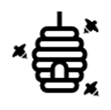
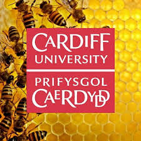
Teacher Resources
Session 1

In Class Activities
Pre-Activity: Draw a Scientist
Draw a scientist. You have 5 minutes to draw what you think a scientist looks like, and what a scientist does. You are welcome to use colour! After the sessions, we will draw a scientist again, and compare.

Activity 1: Build a Bee
Supplies:
- Yellow clay
- Black clay
- Paper and pencil

Let’s make a bee! Use the materials provided to make a bee (Newplast clay in black and yellow) in groups of 2-4. Remember the parts of a bee we just learned; how will your bee collect nectar and pollen? You have 5 minutes to build your bee. At the end of the 5 minutes, the class will display their bees. Vote on your favourite bee and share the winner with @pharmabees.

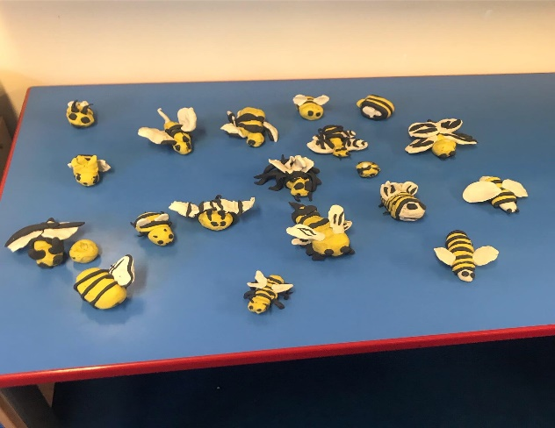
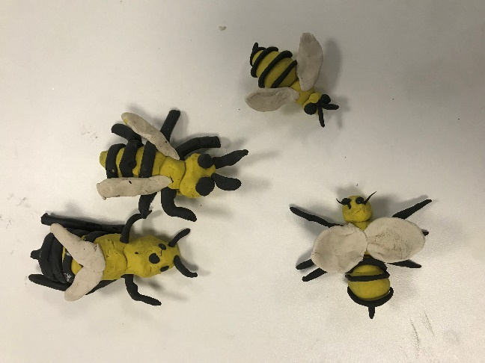

Activity 2: Pollen Activity
Supplies:
- Microscopes
- Pollen slides
- 3D pollen
- Paper and pencil

It’s time for research! Look at the different 3D polled models and compare. Some may be smooth, some spikey, some long and light. Which pollens do you think are pollinated by bees vs the wind?

Teacher: The microscopes need to have the slides ready and focused, and the microscope turned on. It helps to tape the slide into place to prevent it from sliding around when the students are using the microscope.

Look under the first microscope, and draw what you see on your paper. Look under the second microscope and draw what you see on your paper. Compare the two drawings. Note the characteristics of each pollen slide you view. Try to match the pollen you see under the microscope to the 3d pollen model. Can you guess which flowers they came from?

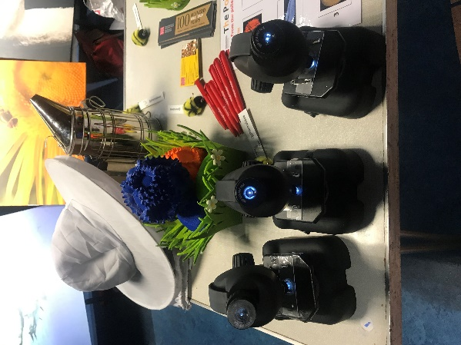
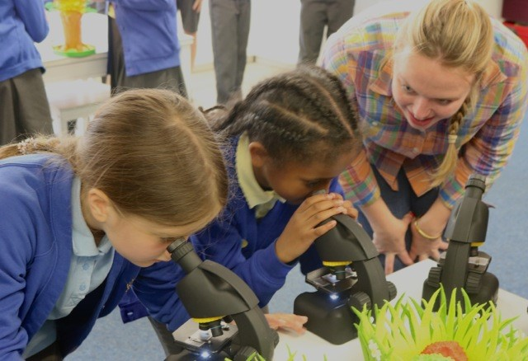

Sources & Resources

Compare the weights of different objects to everyday items with this website:
http://www.weightandthings.com
Honey throughout history:
https://www.nationalgeographic.com.au/history/honey-in-the-pyramids.aspx
https://www.smithsonianmag.com/science-nature/the-science-behind-honeys-eternal-shelf-life-1218690/
https://www.loe.org/shows/segments.html?programID=15-P13-00046&segmentID=7
Bee Hieroglyphs:
https://www.planetbee.org/planet-bee-blog//the-sacred-bee-bees-in-ancient-egypt
Find out more about bee anatomy:
https://askabiologist.asu.edu/honey-bee-anatomy
Bees need water:
https://ucanr.edu/blogs/blogcore/postdetail.cfm?postnum=14566
National Geographic Buzz About Bees:
https://www.natgeokids.com/uk/primary-resource/the-buzz-about-bees/
https://www.natgeokids.com/nz/discover/animals/insects/honey-bees/
Solitary Bees:
https://www.wildlifetrusts.org/blog/ryan-clark/guide-solitary-bees-britain
Other pollinators:
http://www.bbc.co.uk/earth/story/20150514-extraordinary-pollinators
https://www.fs.fed.us/wildflowers/pollinators/animals/unusual.shtml
https://blog.nationalgeographic.org/2014/06/17/beyond-bees-4-surprising-facts-about-pollination/
Reproduction in Plants:
https://www.bbc.com/bitesize/guides/z2xg87h/revision/1
More about beekeeping in California:
https://theconversation.com/a-bee-economist-explains-honey-bees-vital-role-in-growing-tasty-almonds-101421
https://www.ncbi.nlm.nih.gov/pubmed/19610398
Beekeeping in the UK:
http://www.nationalbeeunit.com/index.cfm
Bees Seeing Colour:
https://www.beeculture.com/bees-see-matters/
Traveling Bees:
https://www.scientificamerican.com/article/migratory-beekeeping-mind-boggling-math/
Hand Pollination in China: https://www.huffingtonpost.co.uk/entry/humans-bees-china_n_570404b3e4b083f5c6092ba9?guccounter=1&guce_referrer=aHR0cHM6Ly9jb25zZW50LnlhaG9vLmNvbS8&guce_referrer_sig=AQAAAG53geypc4mxSeAzXpWga4MlLCrfuqVeunf8OgHYpOGWIdMVGfBAcgNPKLuwZOPsZvW5CunCXD6beUhWD_7w9cQSJewbH1nMetpcP27_F0I3Q6hIt0H620P84470hW5Chy63-7glhzFII7AalZEv0BVkDHKvDTX9H7Nh2V3-gNOB
Bees & Blue Honey:
http://newsfeed.time.com/2012/10/05/french-bees-produce-blue-honey/
Bee Decline:
https://www.rsb.org.uk/policy/policy-issues/environmental-sciences/bees
https://www.bbc.co.uk/news/science-environment-47698294
DEFRA Why do bees matter video:
https://www.youtube.com/watch?v=7uVeyH7XQXg
Microscope Magnification:
https://sciencing.com/calculate-total-magnification-5062733.html
Bees Vv. Wasps:
https://www.bbc.co.uk/newsround/45194754

Additional Activities

People, Plants, and Pollinators (Year 6)
https://www.nationalgeographic.org/media/people-plants-and-pollinators/
Have students determine what they think the key message of this video is. Was the speaker effective in getting his or her message across?
Show a short clip to engage students during class, and then have students watch the full video at home and write a paragraph responding to the content or a question you give them.
Have students note statements that represent facts or opinions, including where it’s difficult to tell the difference. What further research might help distinguish facts and opinions? How might the speaker’s viewpoint compare with others’ viewpoints about a topic?

Let’s Debate Activity: Are bees helping or harming the environment?
https://www.npr.org/sections/thesalt/2018/01/27/581007165/honeybees-help-farmers-but-they-dont-help-the-environment?t=1563200188169
https://blog.education.nationalgeographic.org/2018/01/29/honeybees-help-farmers-but-they-dont-help-the-environment/
https://www.unenvironment.org/news-and-stories/story/celebrating-greatest-all-pollinators-bees
https://www.parliament.uk/education/teaching-resources-lesson-plans/primary-school-debating-pack/
Introduce the topic and both sides of the argument briefly. Assign the For and the Against groups. Give time for research, and talk about the importance of citing sources and articles. Then discuss both sides of the argument.
How can we support pollination?
What can you do at your school?
What can you do at home?

Bee Hunt:
Identify different pollinators and bees in your area. Go out to an area and look for different pollinator friendly plants, and different pollinators. Remember, not all pollinators are bees! Please identify 3 plants and 3 pollinators and draw them in your notebooks.
Flower-Insect Timed Count (FIT): if you can spare ten minutes to sit and watch insects and flowers you can carry out a FIT Count (Flower-Insect Timed Count)! This simple survey collects data on the total number of insects that visit a particular flower, ideally chosen from our list of 14 target flowers. FIT Counts can be done anywhere, including gardens and parks, in warm, dry weather any time from April to September. The Flower-Insect Timed Count (FIT Count) is designed to collect new data on numbers of flower-visiting insects, as part of a wider set of surveys under the UK Pollinator Monitoring Scheme (PoMS). Follow the link to download your FIT resources.
https://www.ceh.ac.uk/our-science/projects/pollinator-monitoring
https://friendsoftheearth.uk/bees/bee-identification-guide

Build a bee hotel:
Unlike bumblebees and honeybees, most of our bees do not make colonies but are solitary. The female spends most of her life searching for suitable nesting sites. Some species will nest in holes in the ground, while others will look for old beetle holes or hollow stems in which to lay their eggs. the females will lay their eggs inside the stems of your hotel. Each egg is left with a store of pollen for the grub to eat when it hatches. The egg is sealed up behind a plug of mud, in a ‘cell’, and one stem may end up with several ‘cells’ in it. The young bees will emerge the following year. If you can provide a suitable home, these bees will come to you! You may see a rare bee species, so keep an eye out.
https://www.wildlifetrusts.org/actions/how-make-bee-hotel
https://www.nationalgeographic.org/media/build-your-own-bee-hotel/
Be sure to monitor the hotel and see which visitors you have!

Traveling bees podcast:
Listen to the podcast about bees traveling around the USA. Each year, millions upon millions of honeybees go on a cross country road trip to make the California almond harvest possible. Bees go on road trips this time of year rented by farmers who need them to pollinate their crops. Robert Smith of NPR's PLANET MONEY team followed one shipment of hives headed for the almond fields of California.
https://www.npr.org/2017/03/09/519500033/bees-travel-cross-country-for-the-california-almond-harvest

Build A Bee 2:
Now that you have learned more about bees and pollination, build another bee using materials around the classroom. What materials will us use? How will your bee pollinate and travel around?
Feeling crafty? Try an origami bee: https://www.origami-resource-center.com/easy-origami-bee.html

The Shape of Honeycomb
Learn why bees build honeycomb in the shapes they do. You will need hydrobeads and petri dishes. See a video demonstration and explanation of the activity here: https://www.youtube.com/watch?v=HVfV_J5CcIw&t=2s

Microscope Activity:
You can purchase any microscope that suits your classroom. Here is the microscope we used:
https://www.amazon.co.uk/National-Geographic-Microscope-40x-640x-Smartphone/dp/B016QIPWO8/ref=sr_1_5?adgrpid=51334391257&gclid=CjwKCAjw4NrpBRBsEiwAUcLcDJITiZw_yLJDt8mvgqS2yTdAUOfvy_ib0vNuPhzwZeUUPpgd4Zo8HBoC7NcQAvD_BwE&hvadid=259051504281&hvdev=c&hvlocphy=9045352&hvnetw=g&hvpos=1t1&hvqmt=e&hvrand=10451407867699611123&hvtargid=aud-615477028278%3Akwd-327937676874&hydadcr=28207_1821143&keywords=national+geographic+microscope&qid=1563871850&s=gateway&sr=8-5
You will also need to have students cut 10cm by 10cm squares of paper to draw with. They will need 8 total. Your students will need rulers, pencils, paper and scissors for this activity, as well as the microscope and prepared slides.
Microscopes use lenses to magnify objects. A simple microscope uses only one lens; a magnifying glass could be called a simple microscope. The magnification of a simple microscope doesn't need any calculation because the single lens is usually labelled. A hand-lens, for example, might be labelled with 10x, meaning the lens magnifies the object to look ten times larger than the actual size.
Compound microscopes use two or more lenses to magnify the specimen. We are using a compound microscope today that combines two lenses, the ocular and one objective lens, to magnify the object. The ocular or eyepiece is found at the top of the body tube. The objective lens points down toward the object to be magnified. Most microscopes have three or four objective lenses mounted on a rotating nosepiece. Our microscope has 4x, 10x, and 40x objective lenses, and two options for ocular lenses, 10x and 16x. Rotating the nosepiece lets the viewer change the magnification to what is desired. For example, 10x shows that the lens magnifies an object to appear ten times larger than reality.
To calculate total magnification, find the magnification of both the eyepiece and the objective lenses. The common ocular magnifies ten times, marked as 10x. The standard objective lenses magnify 4x, 10x and 40x. On this microscope, you can also change the ocular to 16x. For example, if we have the ocular at 10x and the objective at 10x, the object in the slide will appear 100x bigger then it normally is.
Q: What are the total magnification options with the ocular at 10x? and the ocular at 16x?
A: 40x, 100x, 400x and 64x, 160x, and 640x
Let’s look at our slide without the microscope. Can you see anything? Draw what you can see on 10cm by 10cm paper. Now turn on the microscope and set the ocular to 10x, and the objective to 4x. What is the total magnification? Draw what you see at 40x. Repeat the drawings for each magnification and compare the differences in the drawings. On the last paper, draw what you think the object would look like at 1000x.
Draw a 1cm by 1cm germ. Draw the germ again if you were to magnify it by 10x. Now by 40x. What about 100x?

