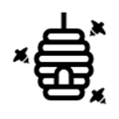
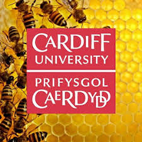
Pharmabees
Session 1 Worksheet

Activity 1: Draw a Scientist
Draw a scientist. You have 5 minutes to draw what you think a scientist looks like, and what a scientist does. You are welcome to use colour!

Activity 2: Let’s make a bee!
Use the materials provided to make a bee. Remember the parts of a bee we just learned; how will your bee collect nectar and pollen? You have 5 minutes to build your bee. At the end of the 5 minutes, the class will display their bees. Vote on your favourite bee and share the winner with @pharmabees.

Activity 3: Researching Pollen
Look at the different 3D polled models and compare (Some may be smooth, some spikey, some long and light). A game board will be provided. Place the 3D pollen models onto the game board. Read the description cards and match the descriptions to 3D pollen models on the game board. After you match all the descriptions with the models, peel back the paper to reveal which plant the pollen came from. After you complete the pollen game, you can observe 2 types of pollen under the microscope.
- Which pollens do you think are pollinated by bees vs the wind? Why?

Look under the first microscope, and draw what you see on your paper. Look under the second microscope and draw what you see on your paper.

1. | 2.

Compare the two drawings. Note the characteristics of each pollen slide you view. Try to match the pollen you see under the microscope to the 3d pollen model. Can you guess which flowers they came from?

1.

2.

